Pig urine for metabolomics LC-MS analysis (C18, HSS T3) (2017)
Chemicals
Acetonitril (ACN) (VWR)
Formic acid (FA)
Glycocholic acid (Glycine-1¹³C)
p-chlorophenylalanine

Solutions
H₂O/ACN/ formic acid (95/5/0.1)
(950 ml MILLIQ-water added 50 ml acetonitril and 1 ml FA.)
ACN/IS: Internal standard solution (concentration: 0.1 mg / mL; final concentration: 0.01 mg / mL). Calculation, see bottom of document.

Materials
2 ml Eppendorf tubes
Pipettes and pipette tips
Centrifuge

Intern standards (IS)
Glycocholic acid (Glycine-1¹³C) solution in methanol (final concentration of 1 mg/ml)
p-chlorophenylalanine solution in 2 % formic acid (final concentration 1 mg/ml)

Sample preparation
- 180 μl urine is mixed with 20 μl ACN/IS
Blank sample: H₂O treated as a sample
QC sample: 20 μl pool of each urine sample is treated as a normal sample
Blind: 0.1% FA
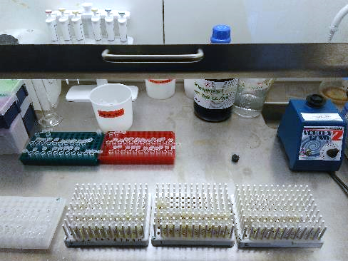

- Protein precipitation in the fridge (20 min, 4°C).
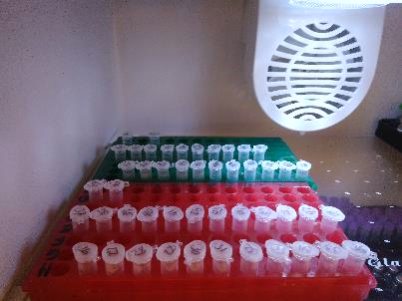

- Centrifugation (10 min, 13,200 rpm, 4°C).
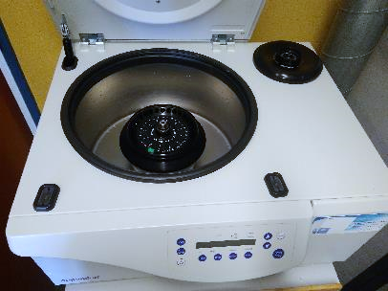

- The supernatant is transferred to vials with micro inserts (150 μl).
- Analysis on UHPLC-MS with C18 column (HSS T3) according to LC-MS procedure.
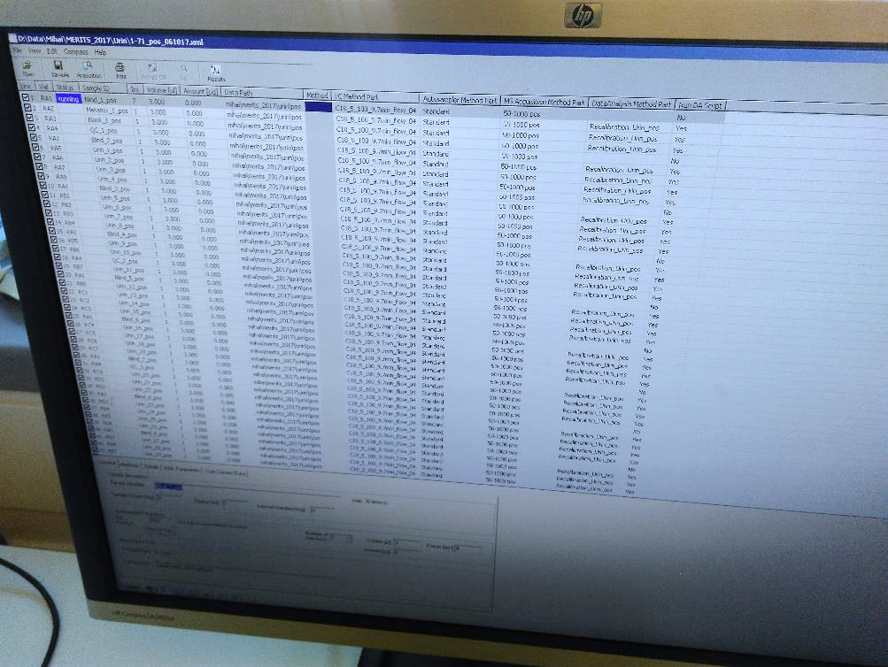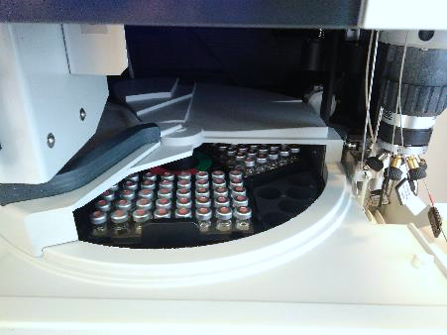

Preparation of ACN and IS solution, pig urine

Urine samples
Total samples: 20 urine samples + 2 QC + 1 blank = 23 samples
V_{per sample}: 25 µL
V_{in total} = 0,025 mL * 23 samples = 0,575 mL -> 1 mL ACN + IS

Internal standards in ACN
Final concentration in urine samples c_{2, urine + ACN} = 0,01 mg/mL
V_{2, urine+ACN} = 0,20 mL
V_{1, ACN} = 0,02 mL
$$C_{1}= \frac{0,01{mg}/{mL}*0,20 mL}{0,020 mL}=0,1 {mg}/{mL}$$

Volume of IS in ACN
p-chlorophenylalanine c_{1, p-chloro.} = 1,0 mg/mL (evt. 2,0 mg/ml)
$$V_{1}= \frac{0,10{mg}/{mL}*1 mL}{1,0{mg}/{mL}}=0,1 mL$$

Glycocholic acid c_{1, glycocholic acid} = 1,0 mg/mL
$$V_{1}= \frac{0,10{mg}/{mL}*1 mL}{1,0{mg}/{mL}}=0,1 mL$$

Volume of ACN
V_{ACN} = 1 mL – (0,1 mL + 0,1 mL) = 0,8 mL

LC-MS settings
Liquid Chromatography system
Column: Waters HSS T3 (C18) UPLC column, 1.8 um, 100 x 2.1 mm.
Precolumn filter: Waters VanGuard Precolum, 2.1 x 5 mm.
Total Run time : 9.7 min
LC flow: 0.400 µL/min
Column temperature: 30°C
Eluents: B line – ACN + 0.1% formic acid; A line – MILLIQ water + 0.1% formic acid
Gradient: Multi-step gradient: 5% B for 2 min, 5% B to 70% B for 8 minutes; 70%B to 100% B for 0.5 min; hold 100% B for 1 min; Return, 0.2 min 100% B to 5% B.
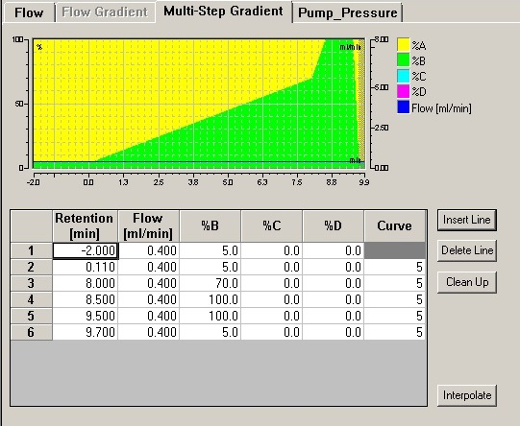
Mass Spectrometry System; Electrospray Ionisation (ESI)
Mode: positive and negative
Capillary voltage: POS – 4500V; NEG – 3600V
End plate offset voltage: 500V
Dry gas flow: 10 L/min
Nebulizer pressure 2.2 bar
Scan range: 50 to 1000 m/z
Sampling rate: 1 Hz
MS scan collision energy: 6 eV.
External calibrant: Li Formate clusters.

